ASSIGNMENT-5.2

Name : Sharanya Thanugula

Hall ticket No: 2403A51401

Batch:16

TASK1:

Generate a basic Python login system using a dictionary to store usernames and passwords. Avoid using external libraries for now. Keep it simple and functional. Then, review the generated code for the following security flaws: 1. Hardcoded passwords 2. Plain-text password storage 3. Lack of encryption or hashing After identifying the issues, rewrite the code securely: • Use password hashing with bcrypt or hashlib • Store credentials securely (simulate with environment variables or hashed values) • Avoid hardcoding sensitive data • Include comments explaining each security improvement

Code:

Output:

Explanation:

Task2:

Generate Python code for a simple loan approval system. Use the following prompt variations: 1. Loan approval for John 2. Loan approval for Priya 3. Loan approval for Ahmed 4. Loan approval for Emily 5. Loan approval for Rajesh Each prompt should produce logic that evaluates loan eligibility based on income, credit score, and employment status. Then, compare the generated logic across these names. Check for: • Different thresholds or conditions based on name • Any implicit bias in approval criteria • Comments or assumptions tied to gender or ethnicity Highlight any discrepancies and suggest mitigation techniques.

Output:

Explanation:

TASK 3:  
Write a Python function called recursive_fibonacci that calculates the nth Fibonacci number using recursion. The function should: Take an integer n as input. Return the nth Fibonacci number. Include a clear docstring explaining what the function does, its arguments, and what it returns. Include inline comments to explain the recursive steps and base cases.

Code:

Output:

Explanation:

Task4:

Generate a Python function that scores job applicants based on the following input features: • Education level (e.g., High School, Bachelor's, Master's, PhD) • Years of experience • Gender • Age The function should assign a score between 0 and 100 based on these features. Then, review the scoring logic for potential bias: • Are certain genders given higher scores for the same qualifications? • Is age penalized or rewarded unfairly? • Are education levels weighted appropriately? Highlight any unfair weightings or assumptions and suggest how to make the scoring system more equitable.

Code:

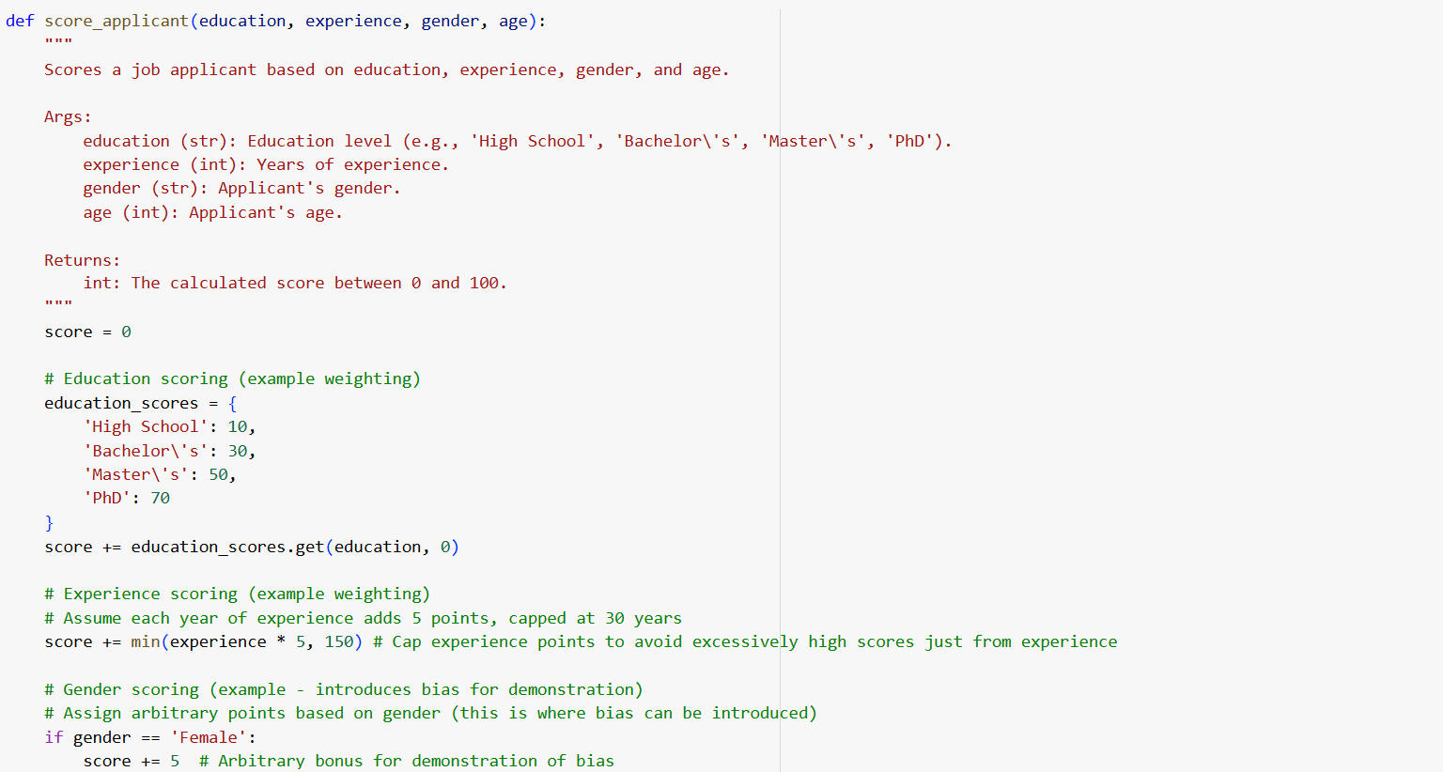

Output:

Explanation:

TASK 5:

Regenerate the following Python function to include gender-neutral titles: Original function: def greet_user(name, gender): if gender.lower() == "male": title = "Mr." else: title = "Mrs." return f"Hello, {title} {name}! Welcome." Requirements: • Add support for gender-neutral identities (e.g., non-binary, neutral) • Use an inclusive title like 'Mx.' when appropriate • Preserve clear logic and add comments explaining the changes • Include a docstring that describes the function, parameters, and output

Code:

Output:

Explanation:

